CSIS 3175--002 Android Final Project

JongHun Yun(300224025)

This application title is ‘Pig E Bank’. This app provides each individual accounts, summaries, and graph, so users can save the money easily with the purpose. Also, users can set up the plan because this app notices how many days left until the due date. Furthermore, they save money in the other accounts with different purposes.

For feature specification, this app start with login activity. If users do not have accounts, users can sign up. After users log in to the account, they can make accounts. After users make accounts, they can update or delete the account or user write the summary of the saving money as users go into the account. In the account, users add, update, or delete the summary and they can check the summary with the list or graph.

This app is combination of D-day application and money saving application. When I start this project, I try to make the money saving accounts with the due date and goal. This application shows you how many percentages proceed and how many days left until due date for each account. Also, users can make summaries not only saving the money, but also spending the money when they save the money. Furthermore, users can check which income categories or expense categories are most and least.

In this application, I use several new concepts. There are a progress bar, animation effect, sqliteopenhelper class, fragments, floating action button, the MP android chart library, Custom dialog, Alter dialog, Date picker with simple date format, custom toolbar, custom menu with ‘home’ button, and overriding the back press button. Also, three custom adapters for the list view are created.

For this application, you need to use NEXES 5 API24 emulator, and the version of Android studio is 3.5.0

This is Splash Activity. When users click the app, this screen pops up and it goes to Login Activity after 3 seconds.

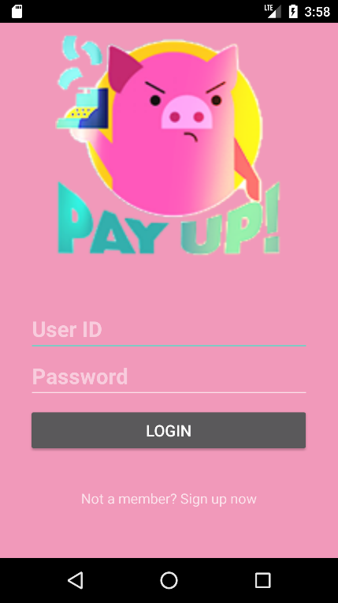

This Activity is Login Activity. If users have a account, they can go into individual account or they can go to signup Activity if they do not have an account as they click the ‘Not a member? Sign up Now’ Text view

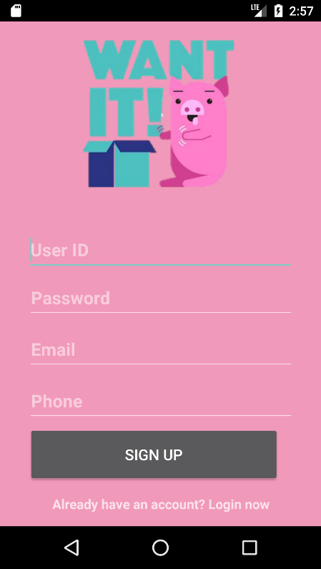

This Activity is Sign up Activity. They can create an account as they fill all the form correctly. If users make an account or Click ‘Already have an account? Login now’, users can go back to login page.

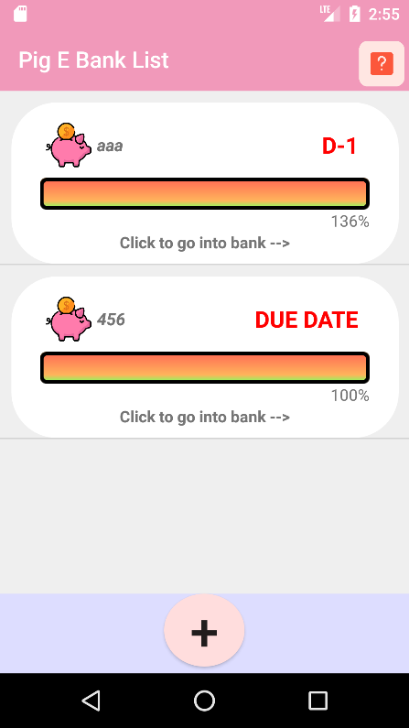This activity is Pig E Bank List Activity. At this activity, users can make an piggy bank account as they click ‘+’ button. Moreover, users can see ‘Help instruction’ if they click the ‘?’ icon. After they make an account, they can go into individual accounts if they click the account. Furthermore, users can go to the update or delete option if they long click the account. After they make an account, each accounts shows you how many dates left on the top right corner. Also, progress bar shows how many percentage you achieve.

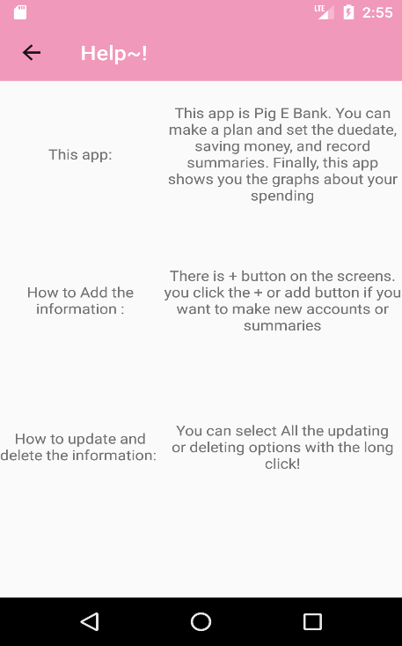

This activity is help activity. This activity teaches you the information how to use this app If you click 🡨 button, users can go back to Pig E Bank list.

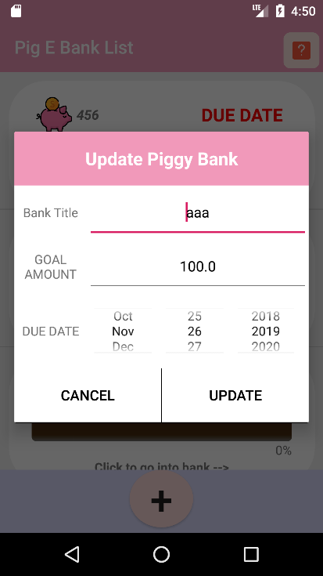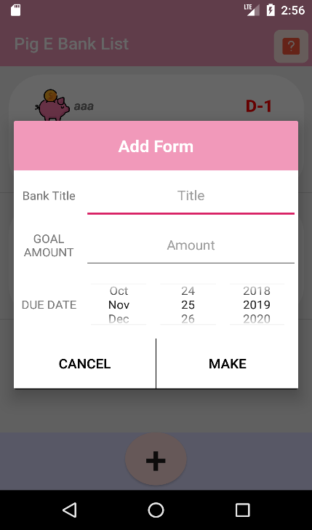

These two activities are ‘add’ and update piggy bank. Users can make a new account when they click make button with filling the forms and set the date. Also, users update form after they change the values with clicking the update button.

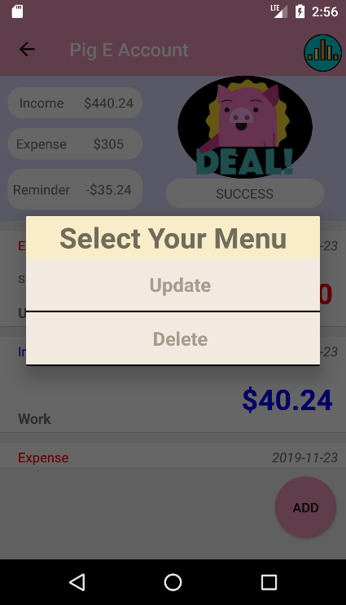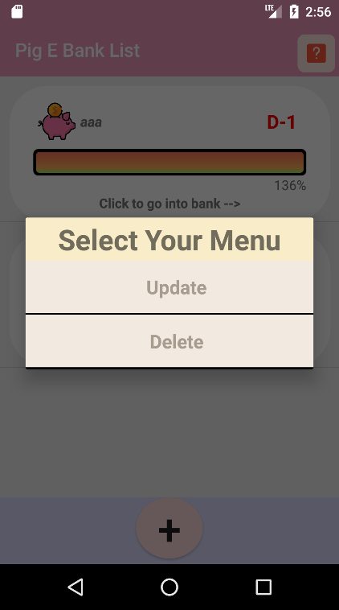

These activities are selecting option activity. If users click the update button, they can go to update activities. If users click delete, users delete the account or the summary(The second activity comes below.)

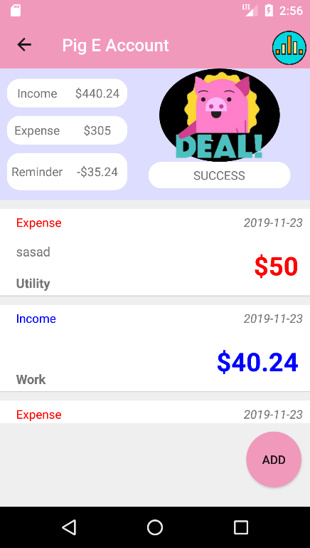

If user click an account, users come to this ‘Pig E Account’ activity. This activity shows you how much income you save and how much money you spend after you save the money. Moreover, this account calculate how much money you need to save to achieve the goal at the text view on the top. Furthermore, the image and description is changed if users achieve goal, expense is more than income and so on. Users add summaries when they click ‘Add’ button. User can see the graphs when they click the graph button on the top right of corner. Users can go back to Pig E Bank list if they click 🡨 button. Users can change or delete the summary if they long click that summary.

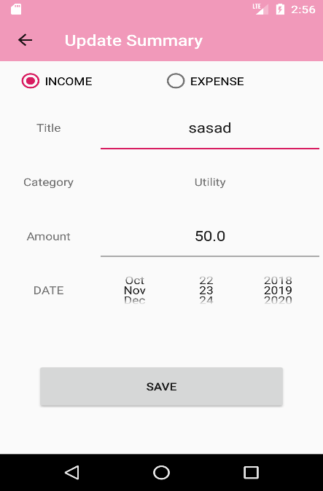

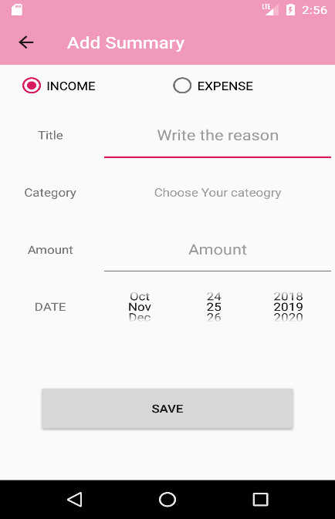Theses activities are add or update the summary of the summary. They can make or update the summary if they click ‘save’ button. If they click the ‘choose Your category’ text, category lists would pop up. Users can go back to Pig E Account if they click 🡨 button. Users can make either income summary or expense summary with the radio buttons on the top

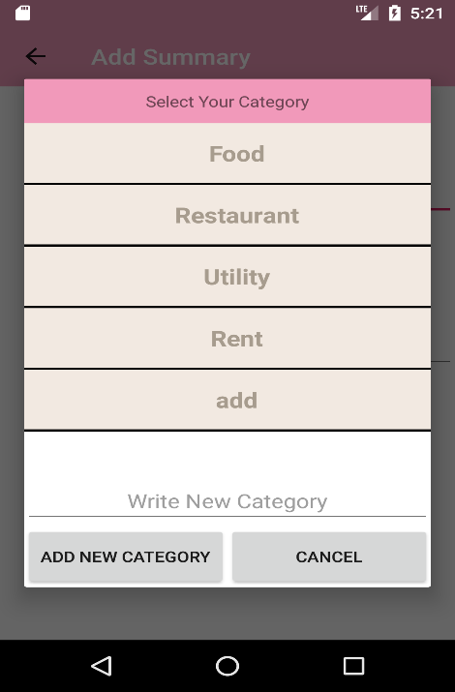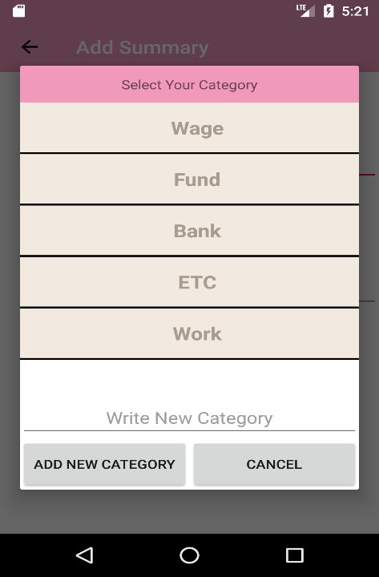These activities come up when user click ‘category’. User can add category as they click the ‘Add New Category’ after they write new category on the edit text. If users select income button, they can get the left list. Users can get the right list if they choose expense button

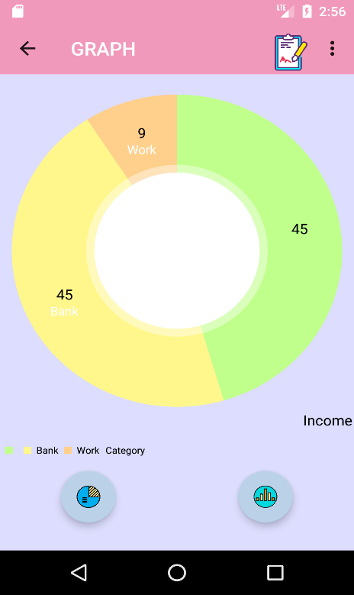

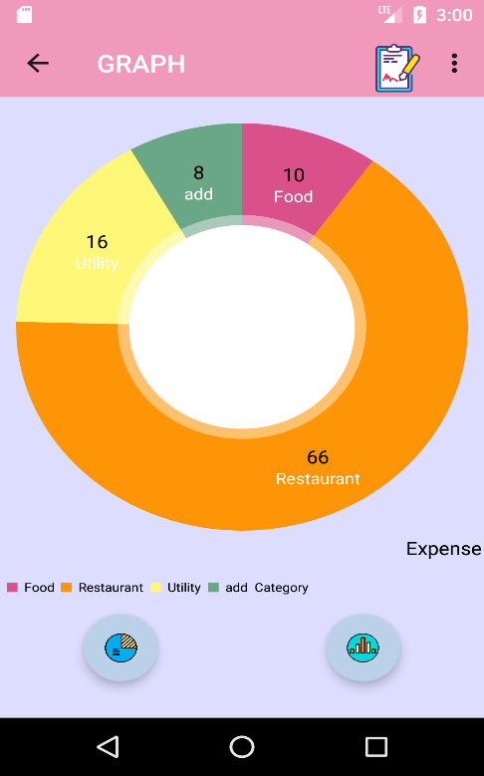Users can come to these activities if they click graph icon at the Pig E Account. User comes to left ‘income pie chart graph’. Users can go to the expense chart if they select the ‘Income’ or ‘Expense’ menu. User can go to the bar graph if they click the right bar graph icon. These graphs shows the summary of the accounts as a graph. User can go back to Pie E account if they click the list icon or 🡨button.

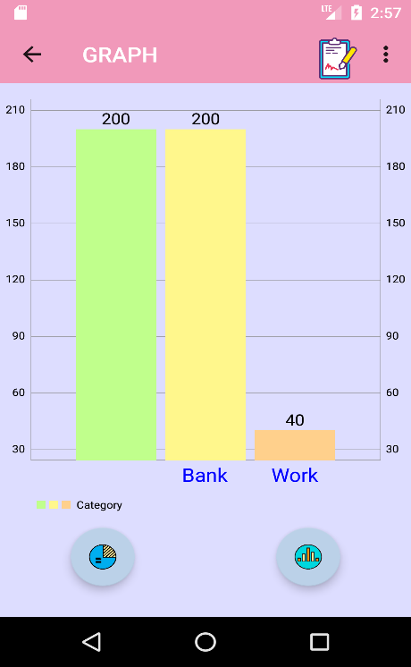

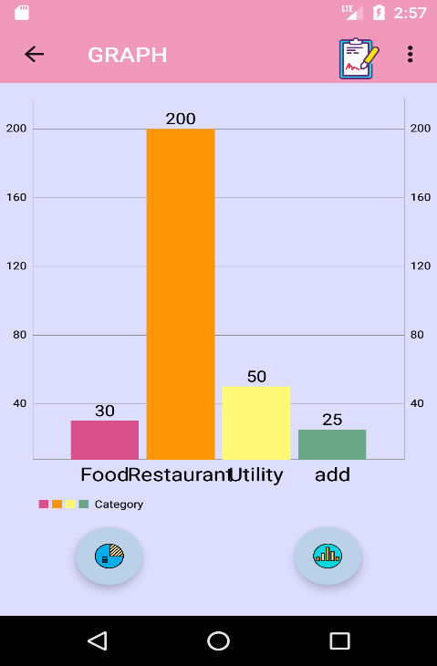These activities show the bar graph and compare which incomes or outcomes are more or less. User can go to pie chart if they click the pie chart icon. They select ‘Income’ or ‘Expense’ graph at the top of the menu. Users can go to the Pig E Account if they click the list icon or 🡨 button.